Assignment 02: ServiceNow Basics

In this exercise, you will apply what you have learned from the first lesson.

Using your personal instance, do the following in the **ServiceNow main browser**:

1. Create a table for organizing and managing your chores.
   1. Title: Chore Chart
   2. Create table fields:
      1. Title (string, max char: 100, mandatory, display)
      2. Description (string, max char: 500)
      3. Complete (boolean)
      4. Chore Priority (choice, choices in this order={Low, Normal, High})

→ Set **Low** as the default choice of the **Chore Priority** field.

**\*Hint**: To create a new table, search for the **Tables** application module in the navigation menu (*All > System Definitions > Tables*).

1. Set up the default table layouts to follow the arrangements.
   1. Organize the list layout in this order:
      1. Title → Leftmost column
      2. Description
      3. Chore Priority
      4. Complete → Rightmost column
   2. Organize the form layout in this order:

|  |  |
| --- | --- |
| Chore priority | Complete |
| Title | |
| Description | |

**\*Hint#1**: List layout can be configured by right clicking the column header of the table list (*Configure > List Layout*).

**\*Hint#2**: Form layout can be configured by opening an existing record and clicking the **Additional Actions** icon. You can organize the form layout either through the **Form Layout** (*Configure > Form Layout*)or **Form Design** (*Configure > Form Design*) menu options.

1. Create a new list view named, **Detailed view**.

**\*Hint**:

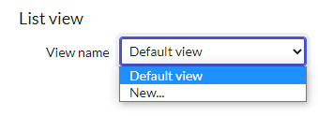

1. Organize the list layout of the Detailed view in this order:
   1. Title → leftmost column
   2. Description
   3. Chore priority
   4. Complete
   5. Created
   6. Updated → rightmost column
2. Create a new form view named, **Task view**.

**\*Hint**:

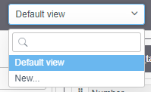 or 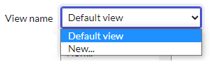

1. Organize the form layout of the Task view in this order:

|  |  |
| --- | --- |
| Title | Created |
| Chore priority | Updated |
| Complete |  |
| Description | |

1. Create application modules for the table in this order.
   1. Create New – creates a new record to the Chore Chart table
   2. All – displays all records of the table
   3. High Priority – displays table records that are designated as uncompleted with a high priority
   4. Completed – displays table records that are designated as completed

**\*Hint**: To create an application menu and modules, search for the **Application Menus** application module in the navigation menu (*All > System Definitions > Application Menus*).

Final Output:

1. Use the *Student Output Template* excel file. Paste screenshots of your activity showing that you had successfully accomplished each task. Put captions above each screenshot.

File name: **<Block_ExerciseNo/Title_Lastname.xlsx>**

Example:

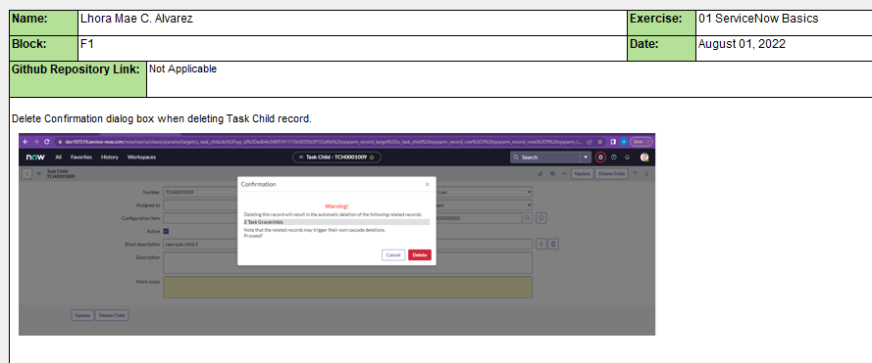

Sample Output:

*1.a. Created table*

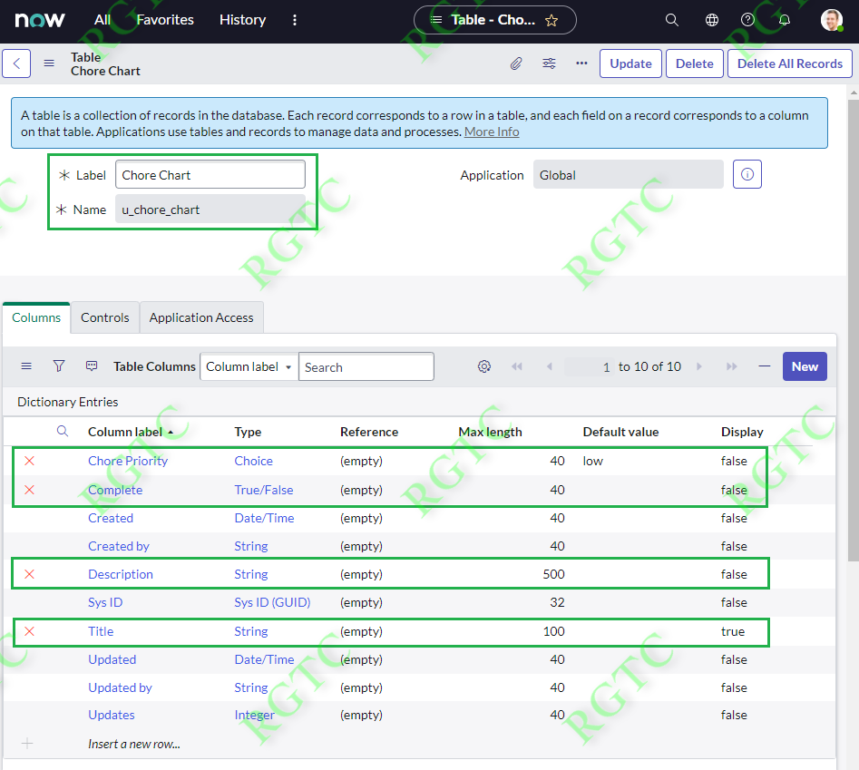

*1.b. Table fields*



*1.c. Chore Priority choices*

